What was the Missouri Compromise?

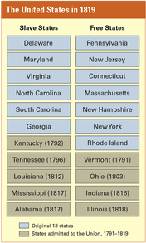
Directions: Read and underling/highlight. Then use the information to respond to the questions at the end.

From the day when Thomas Jefferson drafted the Declaration of Independence, through the debates over the ratification of the Constitution, slavery was clearly an issue that America would be forced to confront. Even though the Constitution outlawed the slave trade in 1808, this only involved the importation of slaves from foreign countries, not the buying and selling of slaves within the United States. As the country expanded, the argument over slavery began to focus on the admission of new states to the union, and whether they would be free or slave states.
It is important to realize that while strong abolitionist (anti-slavery) movements were beginning to gather force in America, the slavery debate was more about politics and economics than morality and ethics. The 3/5 compromise in the Constitution gave the slave states a political advantage over the free states. Every new state added to the country meant two more Senate votes and an additional number of votes in the House of Representatives, to be based off that state’s population. Both slave states and free states wanted more votes to maintain more political power.
Of course, there was an economic dimension to the issue. Wage-paying northerners were forced to compete against slave labor in the south. For southerners, wealth was land. With new technology that allowed cotton to be harvested faster, and an increase of factories in the North,, the market for cotton was booming. Slave-holding southerners needed more land to grow more cotton to sell to the factories in the North and England. More slaves were needed to work that land. If gaining new land to plant meant creating new states, slaveholders wanted them to be slave states.
By adding massive real estate to the equation under the Louisiana Purchase, the slave state-free state issue threatened the unity of the country, particularly in 1820 in the case of Missouri. For weeks, Congress struggled to decide whether Missouri should be admitted to the union as a slave state. As the debate dragged on and tempers wore thin, Southerners began using such dreaded words as secession (to break away) and civil war. “If you persist,” Thomas Cobb of Georgia warned, “the Union will be dissolved. You have kindled a fire which a sea of blood can only extinguish.”
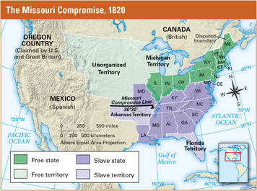
Rather than risk the breakup of the Union, Congress finally agreed to a compromise crafted by Representative Henry Clay of Kentucky. The Missouri Compromise of 1820 admitted Missouri to the Union as a slave state and Maine as a free state. In this way, it maintained the balance of power between slave and free states. At the same time, Congress drew an imaginary line across the Louisiana Purchase at latitude 36°30ʹ. North of this line, slavery was to be banned forever, except in Missouri. South of the line, slaveholding was permitted.
The Missouri Compromise kept the Union together, but it pleased few people. In the North, congressmen who voted to accept Missouri as a slave state were called traitors. In the South, slaveholders deeply resented the ban on slavery in territories that might later become states.
Meanwhile, as Secretary of State John Quincy Adams recognized, the compromise had not settled the future of slavery in the United States as a whole. “I have favored this Missouri compromise, believing it to be all that could be effected [accomplished] under the present Constitution, and from extreme unwillingness to put the Union at hazard [risk],” wrote Adams in his diary. “If the Union must be dissolved, slavery is precisely the question on which it ought to break. For the present, however, the contest is laid asleep.”

Questions: Respond in bullet-note form
- What were the issues behind the Missouri Compromise…
  - Politically?

  - Economically?

  - Socially?

  - Geographically?

- How did the Missouri Compromise attempt to maintain a balance of power in Congress?

- Why was the Missouri Compromise only a temporary solution?

