From Compromise to Crisis – Secession of the South and the Start of the Civil War

Directions: Read and underline/highlight the information below.

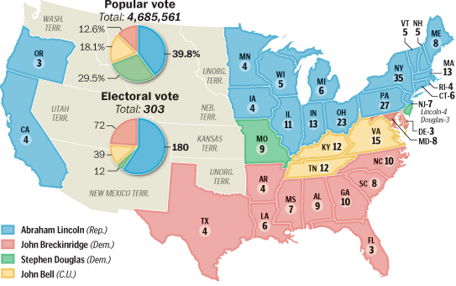
The Election of 1860: The 1860 presidential race showed just how divided the nation had become. The Republicans were united behind Lincoln. The Democrats, however, had split between Northern and Southern factions (in other words, they split into 2 separate groups). Northern Democrats nominated Stephen Douglas for president. Southern Democrats supported John C. Breckinridge of Kentucky. The election became even more confusing when a group called the Constitutional Union Party nominated John Bell of Tennessee.

With his opposition divided three ways, Lincoln sailed to victory. But it was an odd victory. Lincoln won the presidential election with just 40 percent of the votes, all of them cast in the North. In ten Southern states, he was not even on the ballot. For white Southerners, the election of 1860 delivered an unmistakable message. The South was now in the minority. It no longer had the power to shape national events or policies. Sooner or later, Southerners feared, Congress would try to abolish slavery. And that, wrote a South Carolina newspaper, would mean “the loss of liberty, property, home, country—everything that makes life worth living.”

The South Secedes from the Union: In the weeks following the election, talk of secession filled the air. Alarmed senators formed a committee to search for yet another compromise that might hold the nation together. They knew that finding one would not be easy. Still, they had to do something to stop the rush toward disunion and disaster. The Senate committee held its first meeting on December 20, 1860. Just as the senators began their work, events in two distant cities dashed their hopes for a settlement.
In Springfield, Illinois, a reporter called on President-Elect Abraham Lincoln. When asked whether he could support a compromise on slavery, Lincoln’s answer was clear. He would not interfere with slavery in the South. And he would support enforcement of the Fugitive Slave Act. But Lincoln drew the line at letting slavery extend into the territories. On this question, he declared, “Let there be no compromise.”
Meanwhile, in Charleston, South Carolina, delegates attending a state convention voted that same day—December 20, 1860—to leave the Union. The city went wild. Church bells rang. Crowds filled the streets, roaring their approval. A South Carolina newspaper boldly proclaimed, “The Union Is Dissolved!” Six more states soon followed South Carolina’s lead. In February 1861, those states joined together as the Confederate States of America.

The Civil War Begins: On March 4, 1861, Lincoln became president of the not-so-united United States. In his inaugural address, Lincoln stated his belief that secession was both wrong and unconstitutional. He then appealed to the rebellious states to return in peace. “In your hands, my dissatisfied fellow countrymen, and not in mine,” he said, “is the momentous issue of civil war.”
Once in office Lincoln faced a crucial decision. Lincoln said that the Federal government would not abandon its property and bases in southern states, but Fort Sumter in Charleston harbor and Fort Pickens needed supplies. Time was running out for the garrison at Fort Sumter. If Lincoln withdrew the garrison, he would be recognizing the Confederacy. If he supplied the garrison, he risked war. Om April 4, 1861 Lincoln announced he was sending relief expeditions to the forts, and would fight if necessary. Confederate leaders decided to attack Fort Sumter before the supply ship arrived. For 34 hours, the Confederates fired shells into the fort. The fort’s walls crumbled, quarters caught fire, and Union soldiers were choking from smoke as the fire crept toward the fort’s supply of gunpowder. The fort surrendered with no one killed, but the Civil War had begun.
The war came as no surprise to Americans in the North or the South. It had been brewing for years in the many angry fights over slavery. Americans did not expect, however, that the war would be so long and costly. They thought it would last only two or three months. The Civil War would last for four years, and would result in the deaths of hundreds of thousands of soldiers. Almost every American would be affected by the war in some way. The war would even change America itself.

From http://subscriptions.teachtci.com/shared/sections/8891?program_id=117

